**GROUP 5.9**

**Name - Rushikesh Nalla**

**ID - 201401106**

**Name - Omkar Damle**

**ID - 201401114**

**Class Model**

**CENTRALISED SCHOLARSHIP MANAGEMENT SYSTEM**

**Revised Class Diagram : The class model is attached as PNG file.**

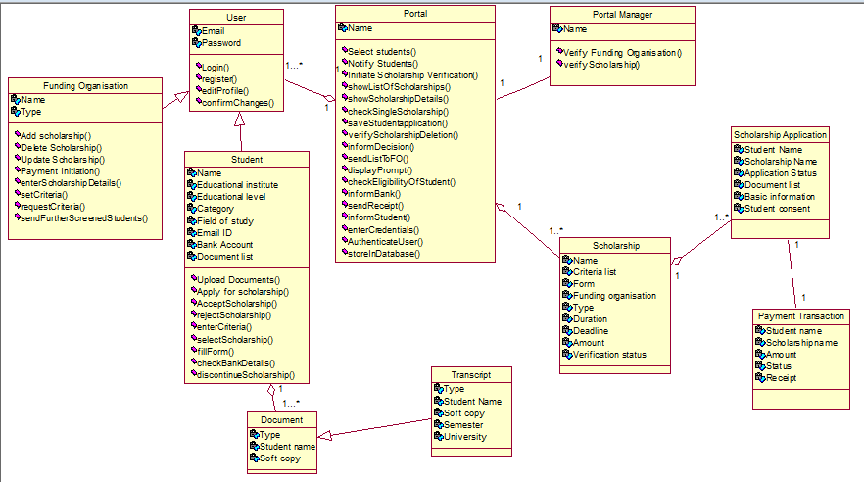

**Revised Class Model after Scenario Walk through :**

|  |  |  |
| --- | --- | --- |
| **Classes** | **Attributes** | **Methods** |
| User | Email,  Password | Login(),  register(),  editProfile(),  confirmChanges(), |
| Student | Student Name, University,  Document list, Education Level,  Field of Study,  Email,  Bank account, Category. | enterCriteria(), selectScholarship(),  fillForm(),  uploadDocuments(), acceptScholarship(), checkBankDetails(), rejectScholarship(), changeBankDetails(),  discontinueScholarship() |
| Scholarship | Scholarship Name, Criteria, Form,  Funding Organization, Scholarship Type, Scholarship Duration, Scholarship Deadline, Scholarship Amount, Verification status |  |
| Funding organisation | Funding Organization Name,  Funding Organization Type | AddScholarship(), UpdateScholarship(),  Payment Initiation(), EnterScholarshipDetails(),  SetCriteria(),  RequestCriteria(),  deleteScholarship()  sendFurtherScreenedStudents() |
| Portal Manager | Name | VerifyFundingOrganization(),  VerifyScholarship() |
| Portal | Name | showListOfScholarships(),  showScholarshipDetails(),  checkSingleScholarship(),  saveStudentApplication(),  VerifyScholarshipDeletion(),  informDecision(),  sendListToFO(),  SelectStudents(),  NotifyStudents(),  displayPrompt(),  checkEligibiltyOfStudent(),  informBank(),  sendReceipt(),  informStudent(),  EnterCredentials(),  AuthenticateUser(),  storeInDatabase() |
| Scholarship Application | Student Name, Scholarship Name, Application status, Documents,  basic information, student consent (if accepted) |  |
| Payment transaction | Student Name, Scholarship Name, Amount,  status,  receipt |  |
| Document | Type,  student name,  soft copy |  |
| Transcript | student name,  type,  semester number, university,  soft copy. |  |